
Covenant 21 Service
Covenant 21 - Covenant for a Gospel People
A text version of the Covenant Service taken from the Covenant for a Gospel People material, originally produced to mark the millennium.

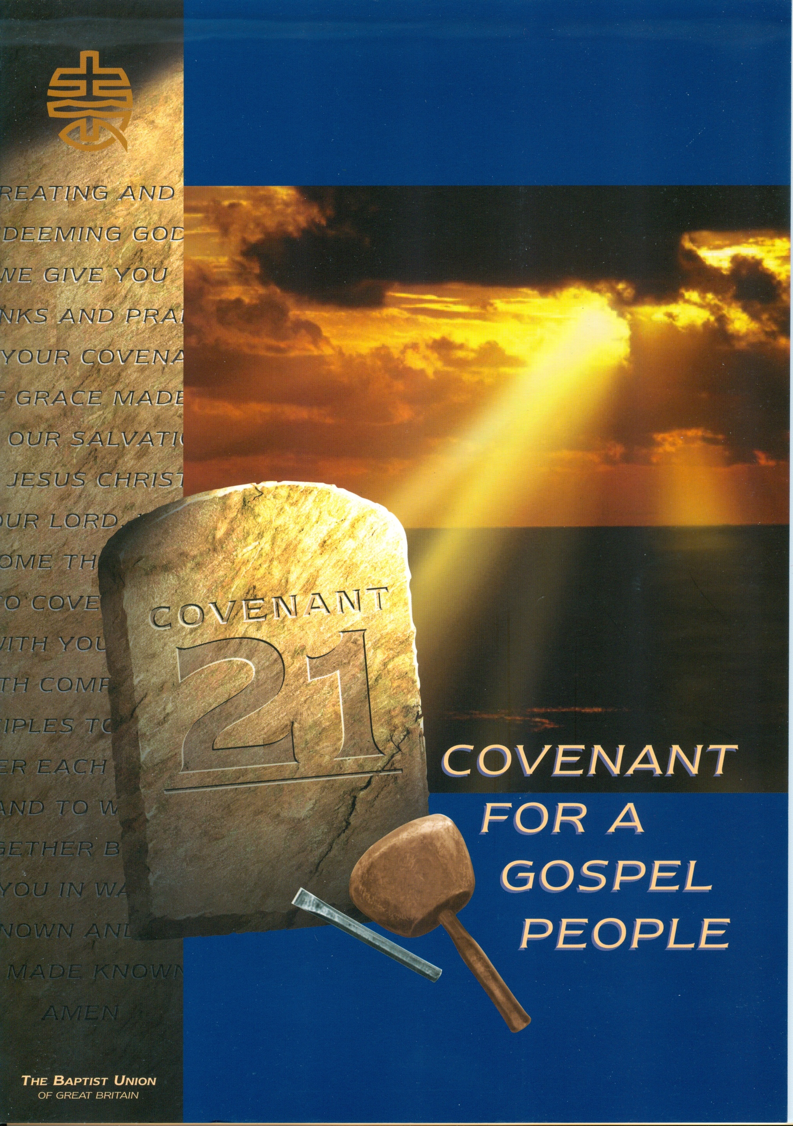

COVENANT SERVICE


WE GATHER

A God makes us a people:
B we are shaped by God's will.

A Jesus calls us together:
B we meet in Jesus' name.

A The Spirit binds us together:
B and leads us into truth.

A We come as a fellowship of believers in God, living under the rule of Jesus Christ:
B seeking his mind through the guidance of the Spirit and the Scriptures.

A We come as a people on a journey with God, open to change:
B ready to discover new ways of being church at this time.

A We come with our various gifts of ministry, given by the Spirit:
B called to share in God's mission of reconciliation in the world.

A We come as people who are free, because Christ is our Lord:
B finding unity in diversity and defending liberty for all.

A We come to make the body of Christ visible in the local congregation:
B and to express the fullness of his body in relationships between the churches.

PRAYER OF CONFESSION

Leader Covenant God,
we confess to you that we are sinful humanity and failing disciples.

Silent prayer ...

We confess
that despite your call, we have not made every effort to maintain the unity of the Spirit in the bond of peace;

All we have sometimes replaced your mission with our own;
we have often been half-hearted in our fellowship-sharing,
and our life together has not always witnessed to your love.
Forgive us, we pray.

Leader By the missionary-grace of your Father's heart,
All make us your missionary people.

Leader By the life-changing forgiveness of Jesus,
All set us free to love one another and your world.

Leader By the heart-cleansing power of your Spirit
All empower us to walk together as your people in the path of obedience.
Forgiving God,
Father, Son and Holy Spirit, forgive and renew us, we pray,
through Jesus Christ our Saviour, Amen.
A song or hymn on the assurance of God's mercy may be sung here.

WE BELIEVE

Leader Together with all God's people, we proclaim our faith and celebrate the story of our salvation.

(Use either The Apostles' Creed, the scriptural affirmation of faith, or an alternative agreed statement.)

THE APOSTLES' CREED

I believe in God, the Father almighty,
creator of heaven and earth.

I believe in Jesus Christ, God's only Son, our Lord,
who was conceived by the Holy Spirit
born of the Virgin Mary
suffered under Pontius Pilate
was crucified, died, and was buried;
he descended to the dead.
On the third day he rose again;
he ascended into heaven,
he is seated at the right hand of the Father,
and he will come to judge the living
and the dead.

I believe in the Holy Spirit,
the holy universal Church,
the communion of the saints,
the forgiveness of sins,
the resurrection of the body,
and the life everlasting. Amen.

A SCRIPTURAL AFFIRMATION OF FAITH

A Hear, O Israel, 'The Lord our God is one Lord'.
In the beginning, God created the heavens and the earth.

B The earth is the Lord's and all that is in it, the world and those who live in it.

A And God said to Moses, 'Say to all the people
‘You shall be holy, because I, the Lord your God, am holy’.

B He has told you what is good, and what does the Lord require of you but to do justice, to love kindness and walk humbly with your God?

A And when the time had fully come, God sent his Son, born of a woman, born under law, to redeem those under law, that we might receive the full rights of children.

B And the Word became flesh and we saw his glory, the glory as of the Father's only Son, full of grace and truth.

A Jesus came to Galilee, proclaiming the good news and saying, 'The time is fulfilled and the Kingdom of God has come near, repent and believe the good news'.

B And this is the judgment, that the light has come into the world, and people loved darkness rather than light because their deeds were evil.

A And when they had mocked Jesus, they took off the purple robe and put his own clothes on him. Then they led him out to crucify him.

B God made him who had no sin to be sin for us so that in him we might become the righteousness of God.

A But this Jesus God raised up, and of that all of us are witnesses.

B For we know that since Christ was raised from the dead, he cannot die again; death no longer has mastery over him.

A While Jesus was blessing them, he withdrew from them and was carried up to heaven.

B Therefore God also exalted him and gave him the name that is above every name

A Jesus told them, 'It is to your advantage that I go away, for if I do not go away, the Advocate will not come to you; but if I go, I will send him to you'.

B Now the Lord is the Spirit, and where the Spirit of the Lord is, there is freedom.

A The body is one, though it is made up of many parts; and though all its parts are many, they form one body. So it is with Christ.

B There is one body, and one Spirit - just as you were called to one hope when you were called: - one Lord, one faith, one baptism; one God and Father of all, who is over all and through all and in all.

A And all will have to give account to him who is ready to judge the living and the dead.

B Shall not the Judge of all the earth do right?

A See, the home of God is with mortals. He will dwell with them, they will be his peoples and God himself will be with them

B He will wipe every tear from their eyes.
Death will be no more, mourning and crying and pain will be no more,
for the first things have passed away.

WE SERVE

A We baptise those who repent and trust in Christ as Lord and Saviour.

B in baptism we are called to be disciples who share in the death and resurrection of Christ.

A Through baptism we are received into the Church, the body of Christ.

B immersed into the fellowship of the Father, Son and Holy Spirit.

A To know Christ is to follow him;

B To name him Lord is to obey him;

All Jesus calls us to be a gospel people.
A song or hymn on the theme of the service may be sung.

Leader Jesus says, 'You shall love the Lord your God with all your heart and with all your soul and with all your mind and with all your strength'.

All He calls us to be a worshipping community, offering all to God in prayer.

Leader Jesus says, 'Go therefore and make disciples of all nations, baptising them in the name of the Father and of the Son and of the Holy Spirit, and teaching them to obey everything I have commanded you'.

All He calls us to be a missionary people, making known the redeeming love of God.

Leader Jesus says, 'If any want to become my followers, let them deny themselves and take up their cross and follow me'.

All He calls us to be a sacrificial community, generously giving from all that God has given us.

Leader Jesus says, 'Anyone who comes to me, I will never turn away'.

All He calls us to be an inclusive community sharing the hospitality of God's Kingdom with all.

Leader Jesus says, 'The Spirit of the Lord is upon me, to proclaim good news to the poor'.

All He calls us to be a prophetic community, challenging powers that oppress and values that corrupt.

WE COVENANT

All pray Creating and redeeming God,
we give you thanks and praise for your covenant of grace
made for our salvation in Jesus Christ our Lord.
We come this day to covenant with you and with companion disciples
to watch over each other and to walk together before you
in ways known and to be made known.
Amen.

A song or hymn on the theme of responding to God in mission may be sung.

Voice 'Those who wait upon the Lord shall renew their
strength. They shall mount up with wings like eagles.
They shall run and not be weary, they shall walk and not faint.'

PRAYER FOR HELP

Leader Covenant God,
strengthening and saving God,
we claim the promises of your Word and ask for your help.

All By the power of your Holy Spirit
Make bold our vision of your kingdom.
Strengthen us to do your will
and help us to walk together in your way.
Pour down your Spirit,
that the promises we make this day, may be an offering of love,
our duty and delight,
and that by our life together we may glorify you,
Father Son and Holy Spirit. Amen.

Voice 'Since we are surrounded by so great a crowd of witnesses, let us also lay aside every weight and
the sin which clings so closely and let us run with perseverance the race that is set before us, looking
to Jesus, the pioneer and perfecter of our faith.'

All This day we give ourselves again to the Lord and to each other
to be bound together in fellowship,
for the sake of the mission and glory of God.
Celebrating our shared life,
we commit ourselves to belonging and working together
in our congregation, our local partnerships,
our Association, and our Union of churches.
We pledge all that we have and all that we are to fulfil God's purposes of love.

A moment of silence ...

All Now may the God of hope fill us with all joy and peace in believing,
that we may abound in hope by the power of the Holy Spirit.

Leader Now to him, who by the power at work within us is able to accomplish abundantly far more than we can ask or imagine.

All To him be glory in the church and in Christ Jesus to all generations, for ever and ever.
Amen.

WE SHARE

Leader As a covenanted people, let us greet one another in the name of the Lord.

ALL SHARE THE PEACE OF CHRIST TOGETHER

THE LORD'S SUPPER
(according to your local church pattern).

At the conclusion a song may be sung.

BENEDICTION
Go forth into God's world in peace rejoicing in the power of the Holy Spirit.
And the blessing of God Father, Son and Holy Spirit be with you all.

Baptist Union of Great Britain Baptist House PO Box 44 129 Broadway Didcot Oxon OX11 8RT
telephone 01235 517700 email faithandsociety@baptist.org.uk website www.baptist.org.uk
BUGB operates as a charitable incorporated organisation (CIO) with registered Charity Number: 1181392

